

Production Release Document
(Digital PL)

(NEWGEN CONFIDENTIAL)

Newgen Software Technologies Ltd.
New Delhi, INDIA

Deployment Document-Digital Personal Loans

Prerequisite for the Deployment
- Admin Username and password to login in omniapp.
- WAS console username and password for deployment of war.
- User Group mapping for the Digital_PL queue
DataBase Activities:

- Execute ‘WI-Creation_Update’ script shared in the release in DBScripts
- Execute ‘External and Transaction Tables’ script shared in the release.
- Execute ‘Masters’ script shared in the release.
- Execute ‘Procedures’ script shared in the release.
- Execute ‘Job’ script shared in the release.

Data Class Configuration
- Login to omnidocs and open system administrator.
- Go to Data Class section and select Export/Inport data class.
- Now import the given dataclassInformation.xml from the release.
- Click on import then done to complete the import.

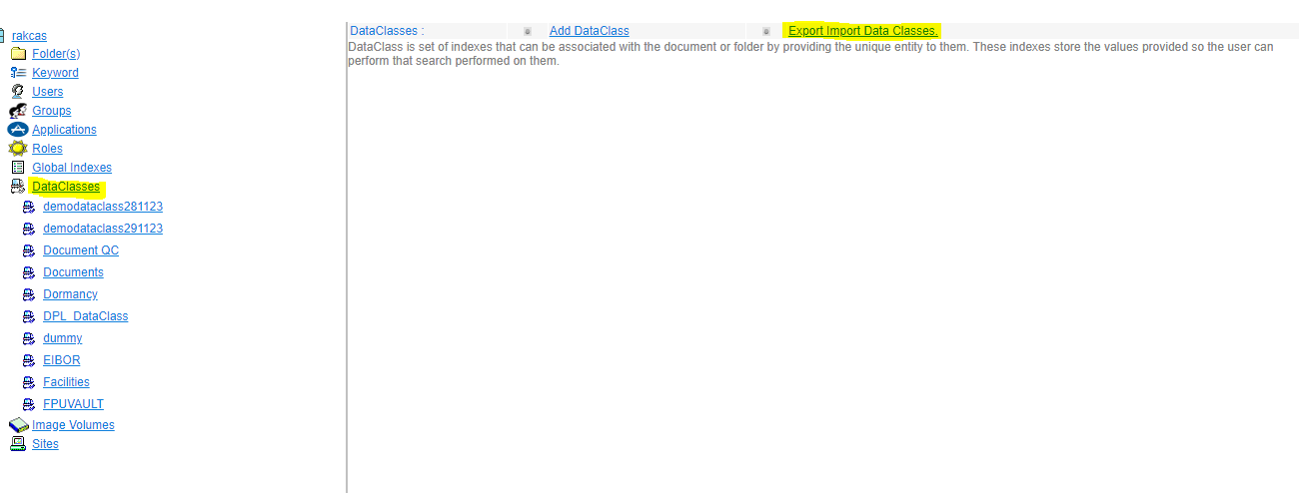
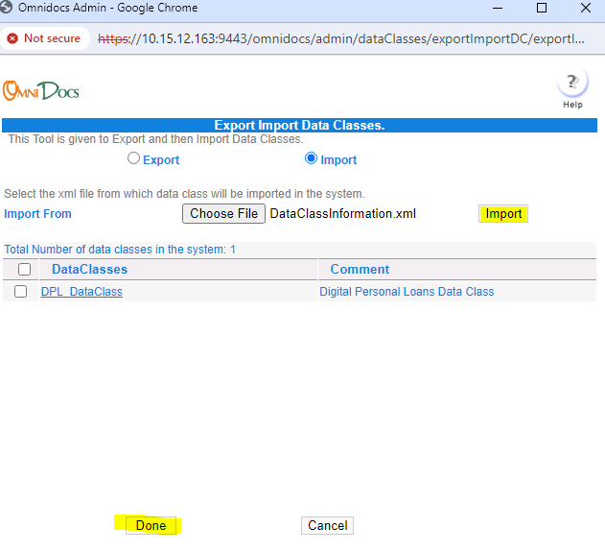

Route Registration:
- Login to Omniapp and Open Process Designer.
- Go to Local -> Import shared Digital_PL route.
- Digital_PL Process will be imported.

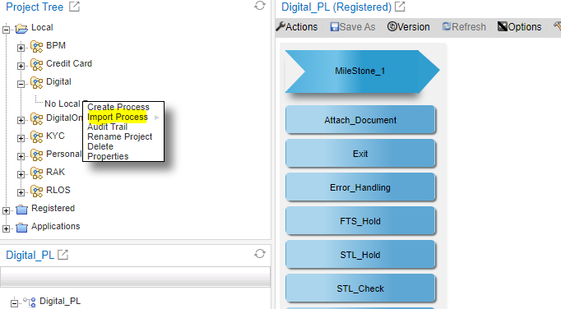

- Change below Setting at Introduction.
Set Starting Sequence No as 1 .

- Archival.
Insert Admin credentials on the above workstep
Archival Path : Digital/PL/&<WorkItemName>&

Associate Data Class : DPL_DataClass

Do the mapping of below listed document as given in the table.

Document Name | Archival Step
Passport_FirstPage | Archival
Passport_LastPage | Archival
Key_Facts_Statement | Archival
Terms_and_Conditions | Archival
Emirates_ID_Front | Archival
Emirates_ID_Back | Archival
MOI | Archival
Insurance_Terms_and_Conditions | Archival
DPL_STP_CAM_Report | Archival
FTS_Statement | Archival
FTS_Statement_Analysis | Archival
DPL_NON_STP_CAM_Report | Archival
DPL_Security_Cheque | Archival
DPL_W9Form | Archival
DPL_SalamContract | Archival
DPL_W8-Form | Archival
DPL_AGENCY_LETTER | Archival
DPL_OnePager | Archival
EMID_Front | Archival
Other Document | Archival
STL | Archival
Entry_Currpassport | Archival
Entry_prevpassport | Archival
Pol_clearance | Archival
Marriage_cert | Archival
Mot_Fathersname | Archival
Wet_signature_form | Archival
EMID_Back | Archival

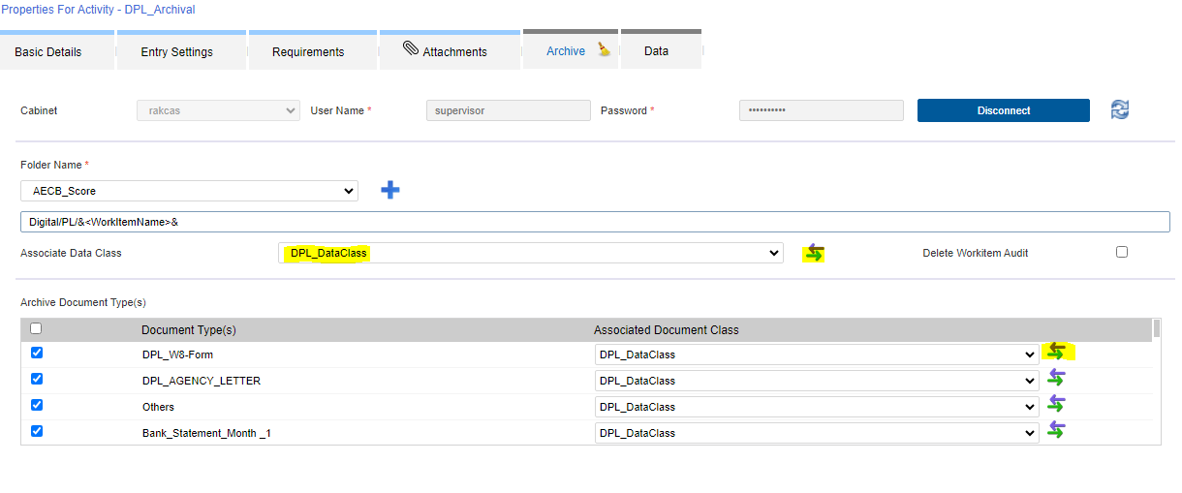

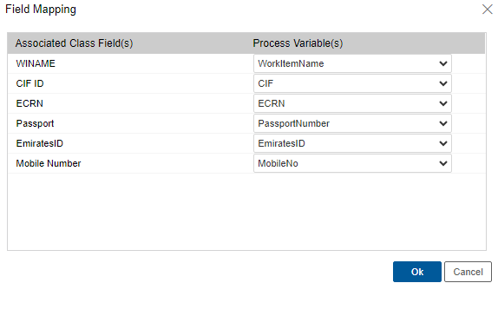
- Right Click on Digital_PL -> Check-in the Process.

Queue Group Mapping:

Do the queue group mapping as below:

QueueName | GroupName | User Name
Digital_PL_Introduction |  | mqserviceuser
Digital_PL_FTS_Hold |  | mqserviceuser
Digital_PL_Attach_Document |  | rakbpmutility
Digital_PL_EFMS |  | DigitalUser
Digital_PL_System_Integration |  | DigitalUser
Digital_PL_Notify_DEH |  | DigitalUser
Digital_PL_Acc_Update_Hold |  | mqserviceuser
Digital_PL_STL_Hold |  | mqserviceuser
Digital_PL_WI_Update_Hold |  | mqserviceuser
Digital_PL_Offer_Letter |  | mqserviceuser
Digital_PL_Doc_Generation |  | DigitalUser
Digital_PL_AWB_Generation |  | DigitalUser
Digital_PL_Courier_Hold |  | mqserviceuser
Digital_PL_LMS |  | DigitalUser
Digital_PL_LMS_WI_UPDATE |  | mqserviceuser

WAS Console activity:

- Deploy Digital_PL.war in WAS Console.

- Give Application Name as NBTL
- Reference Library: omnidocs_library & ibps_library& wfs_library;
- Context Root: /Digital_PL
- Manage Module: class loaded with local class loader first (parent last)

- Deploy below folder at this ‘../AppSrv01/CustomConfig’ location.
- DPL
- Deploy below file at this ‘../AppSrv01/CustomConfig’ location.
- DPL_CAMGen_Config.properties
- Deploy client.js at following location ../webdesktop.war/resources/scripts.
- Update MQService_WICreateEjb at WAS console with shared ‘OmniflowWorkitemCreation.jar’ – to be done during downtime.

Process Management
- Enable Digital_PL Process.
- Go to Digital_PL -> Process Configuration, Enter Context as ‘Digital_PL’ and Select ‘Load IForm from Process Specific War’ option. Then Save.

Right Managements
- Digital_PL_Query
- Go to Object Rights. Select Process Management -> Give View rights and click on Add. After adding select Digital_PL process.
- Give view right to Digital_PL_Query group at ‘DPL_DataClass’ dataclass in OD.
- Select ‘Process Client Worklist’ in Object Type. Check all except Refer, Adhoc Routing, Hold and unhold option. Then Add.

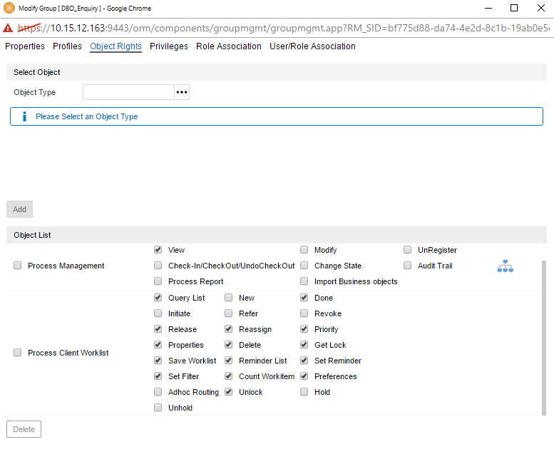

Note : Remove ‘Done’ rights from Process Management from above .

Perform Audit log configuration.

Perform queue group mapping as per the details available in pre-requisites.

Process Variable Mapping

- At Digital_PL_Exception queue add below variables.

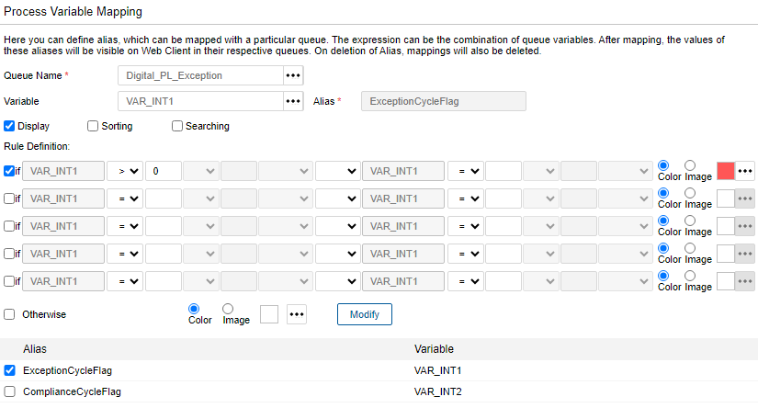

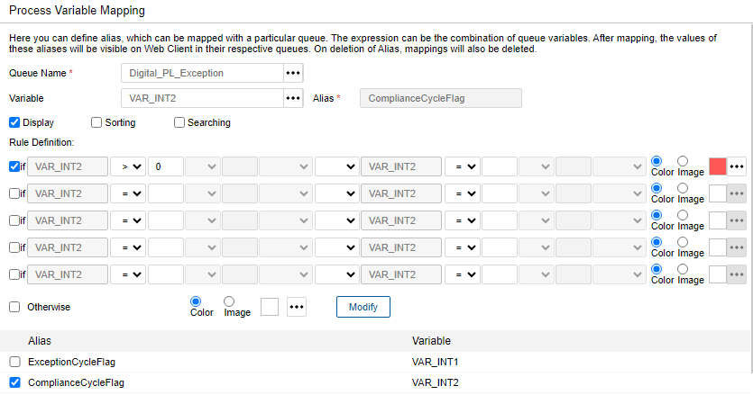

- At Digital_PL_DXT queue add below variable.

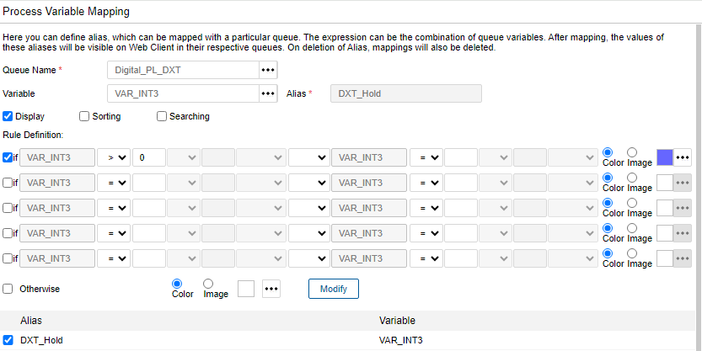

Process Server Registration in ofservices
- Register Digital_PL process server

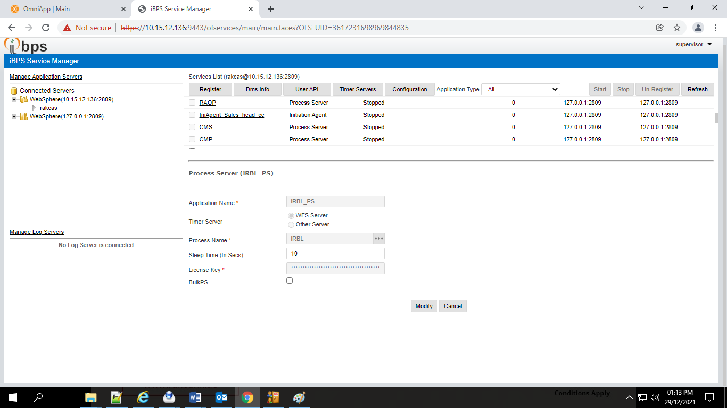

- RAK_RLOS_DocumentUtility

- Go to Services.msc and stop the RAK_RLOS_DocumentUtility
- Replace the falcon_doc_attach.jar at D:\Newgen\Custom Utilities’ path.
- Go to Services.msc and Start RAK_RLOS_DocumentUtility.

Control M job path:

D:\Newgen\Custom Utilites\RAK_RLOS_DocumentUtility\DigitalPL_DocumentAttach\

- RAKDigitalIntegrationUtility

- Go to Services.msc and stop the RAKDigitalIntegrationUtility
- Replace the RAKDigitalIntegrationUtility.jar at D:\Newgen\Custom Utilities’ path.
- Go to Services.msc and Start RAKDigitalIntegrationUtility.
- Deploy below folder at this D:\Newgen\Custom Utilites\ RAKDigitalIntegrationUtility’ location.
1. DPL_Integration
2. Digital_PL Reports
- Deploy the configFiles provided in the release folder to the path
‘D:\Newgen\Custom Utilites\RAKDigitalIntegrationUtility\ConfigFiles’.
- Deploy log4j file from the release folder to the path
‘D:\Newgen\Custom Utilites\RAKDigitalIntegrationUtility\log4jFiles’.
- Deploy the libraries provided in the lib folder to the path
‘D:\Newgen\Custom Utilites\RAKDigitalIntegrationUtility\lib’.
- Deploy the manifest provided in the release to the path
‘D:\Newgen\Custom Utilites\RAKDigitalIntegrationUtility’.

Note: Take Application Server (Linux) restart post clearing temp/wdtemp/wstemp.

- Generate Template Socket UAT

- Go to desktop to check if there is a running instance of Generate_Template, close it by pressing Ctrl+C
- Replace the provided class files from com/newgen/generate to class file in path
‘D:\Custom Utilites\Generate Template Socket Code UAT\com\newgen\generate’.
- Deploy below folder at this ‘D:\Custom Utilites\Generate Template Socket Code UAT’ location.
1. Generated_Template_DPL
- Deploy the given documents in the Templates folder from release to the path
‘D:\Custom Utilites\Generate Template Socket Code UAT\Templates’.

Customer Communication :

- To Email : EmailAddress
- From Email : alerts@rakbank.ae
‎

Rollback Steps:
- Revert executed script.
- Disable process from process manager and remove user group access from initiation.
- Remove rights for report access.
- Revert Utility jar from Back up .
- Revert Utility jar (WI Creation Service) from Back up .

DR Deployment
- Perform all application server related activities given in the release.
- Perform all service server related activities given in the release.

